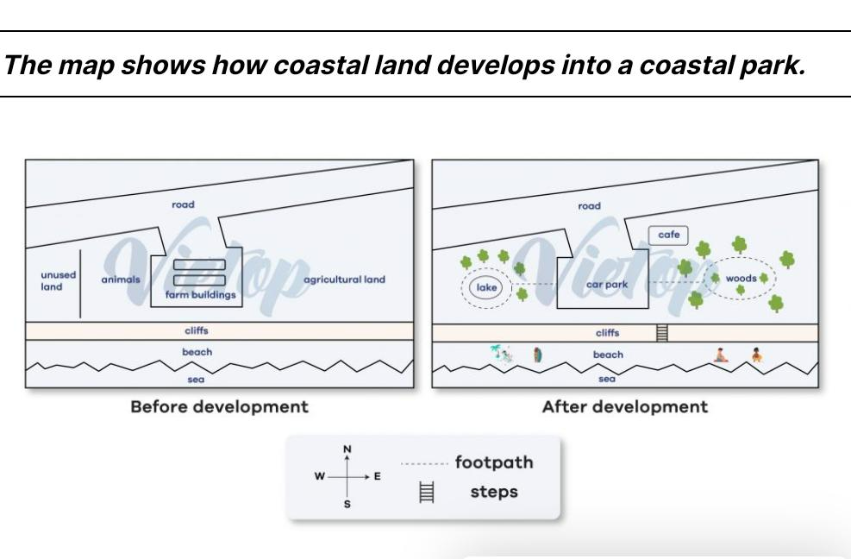

The maps describe the transformation of a coastal land into a park.

Overall, the land in front of the cliff has been upgraded with facilities for the park, while the beach now access easier than before.

Before change, there were farm buildings on the side road and in the centre of the coastal land. To the left of these constructions were unused land and animals, whereas the other side was agricultural land. The cliff was constructed in front the beach and sea.

This place has been converted into a park, which the farm building was translated to the car park. A footpath was built from the wast to the east, surrounding a new lake on the west and woods on the east. Trees were grown along the path, and a new coffee shop was installed behind the car park. The cliff in the front now has ladder to visit sea easily.